EMOLUMENT PROCESS
Submission, Approval & Payroll Sync — Step-by-Step Guide
Prepared for: Fleet Operations & Payroll Team
Document Version: 1.0 | Date: July 2026
Status: Draft — for internal training & UAT reference

Table of Contents
Table of Contents 2
1. Overview 3
1.1 Roles Involved 3
1.2 High-Level Process Flow 3
2. Step-by-Step Process 4
3. Rejection Handling Summary 12
4. Appendix — Full Dummy Data Reference 12

1. Overview
This document describes the end-to-end e-Emolument Form process, from the initial submission of an emolument form by a user through the multi-level approval chain (Duty Officer, Finance Officer, and Central Pay Officer) and final verification and payroll synchronization by the Emolument Admin. This document is intended as a reference guide for training, testing, User Acceptance Testing (UAT), and process documentation purposes.
All names, ship names, ranks, and figures used in this document are dummy data for illustration only and do not represent real personnel or records.

1.1 Roles Involved
Role | Abbreviation | Responsibility
User(Officer / Rate) | — | Submits the emolument form for the relevant period online.
Duty Officer | DO | First-level approver. Reviews and validates/rejects the submission.
Finance Officer | FO | Second-level approver. Reviews after DO approval.
Central Pay Officer | CPO | Third-level approver. Final approval before Emolument Admin stage.
Emolument Administrator | EMOL ADMIN | Verifies fully-approved records and syncs them to the payroll system.

1.2 High-Level Process Flow
The record moves through the following stages in sequence:
User Submission → DO Validation → FO Validation → CPO Validation → Emol Admin Verification & Payroll Sync
Note: If any approver (DO, FO, or CPO) rejects a record, its status is reset to Draft/Null and the entire approval trail is cleared. The record must restart the full approval chain from Submission → DO → FO → CPO.

2. Step-by-Step Process
STEP 1 | User Logs In and Navigates to Emolument Tab (User)

The user logs into the portal using their credentials and selects the "Emolument" tab from the main navigation menu.
Dummy Login Data
Field | Sample Value
Username / Service ID | NN/1100
Password | ••••••••

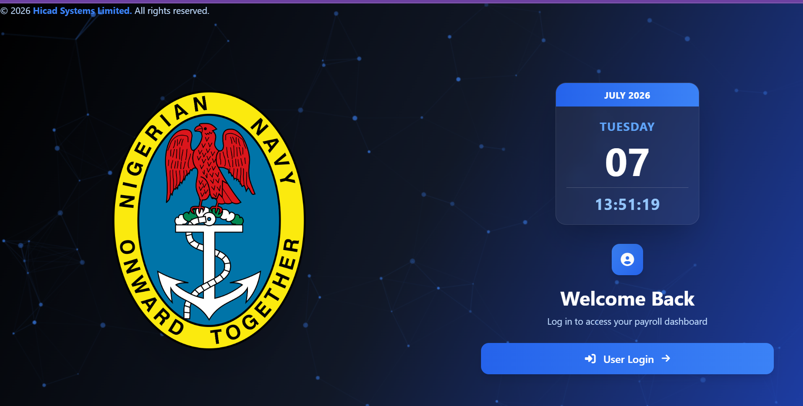
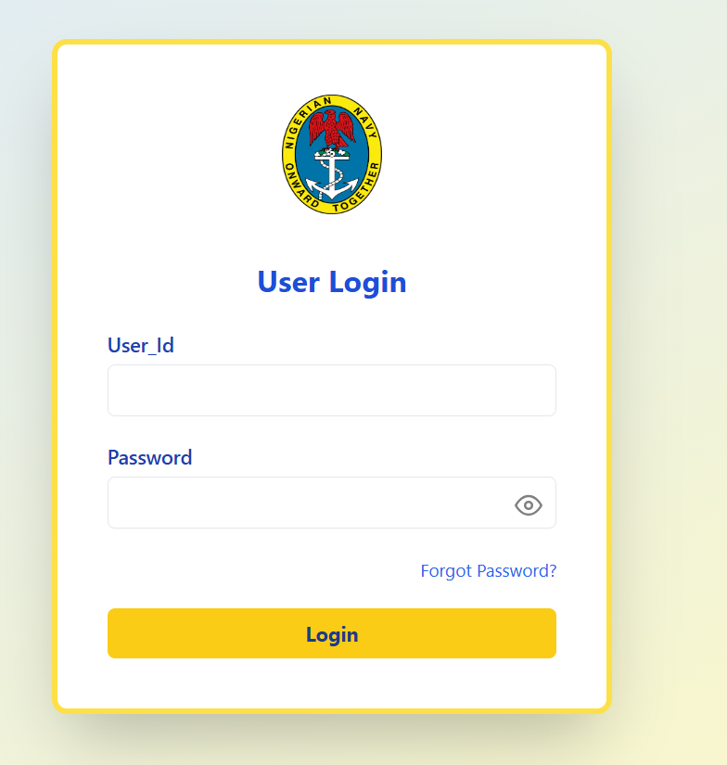

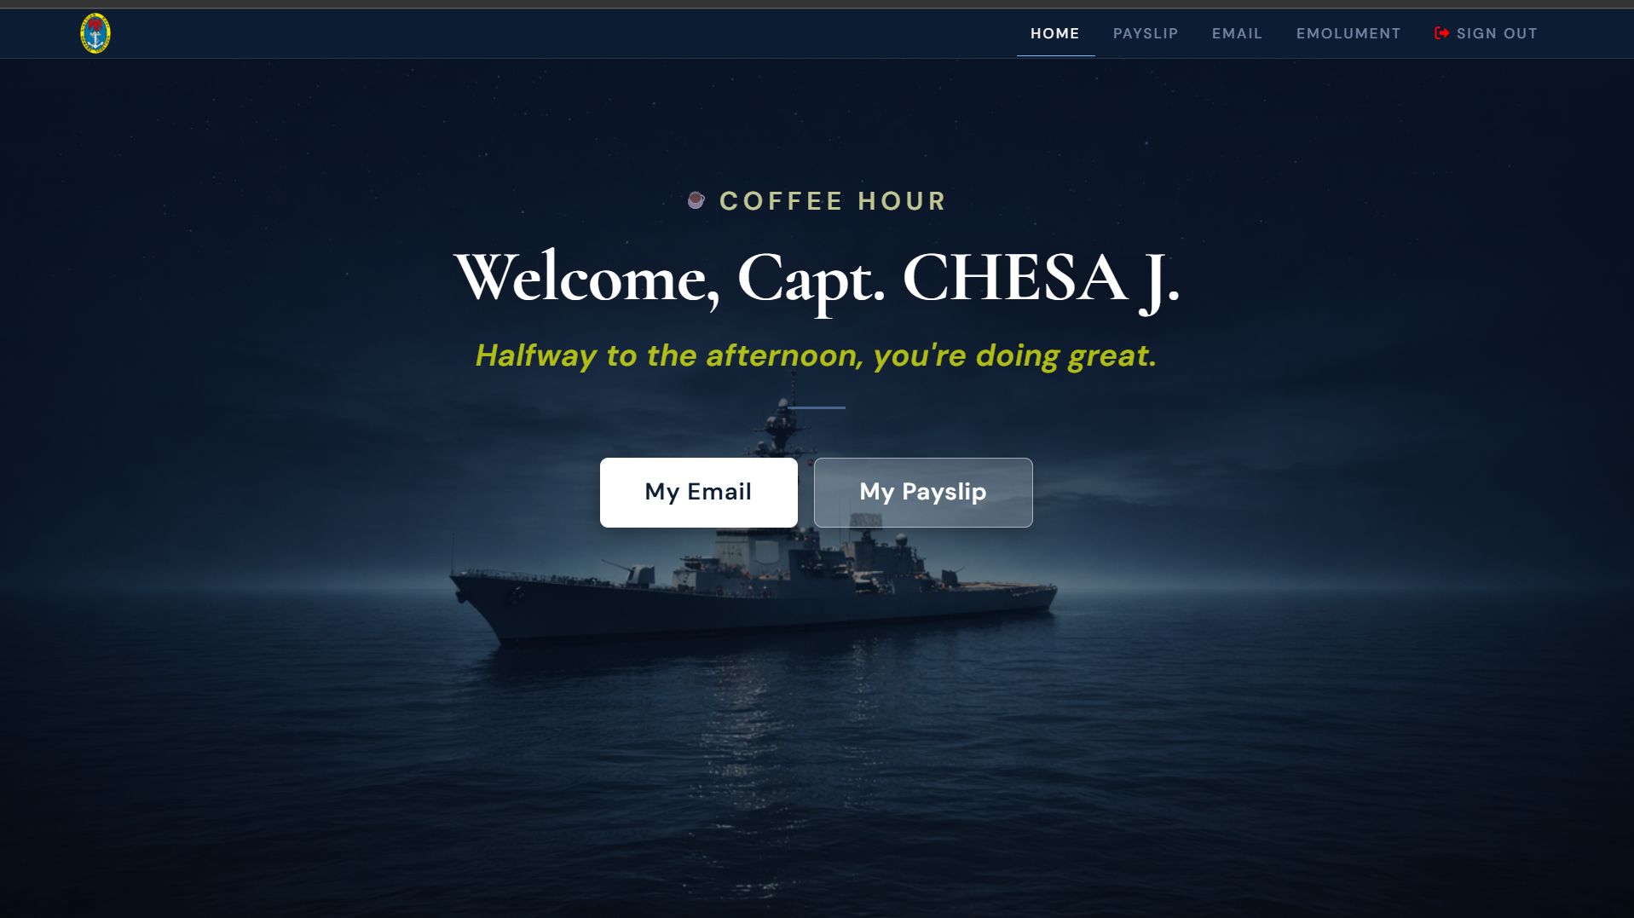
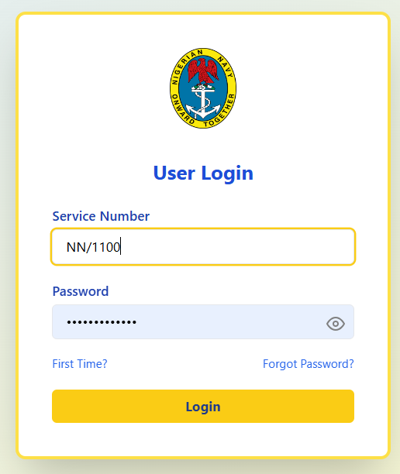
Fig 1.1 — Login Screen
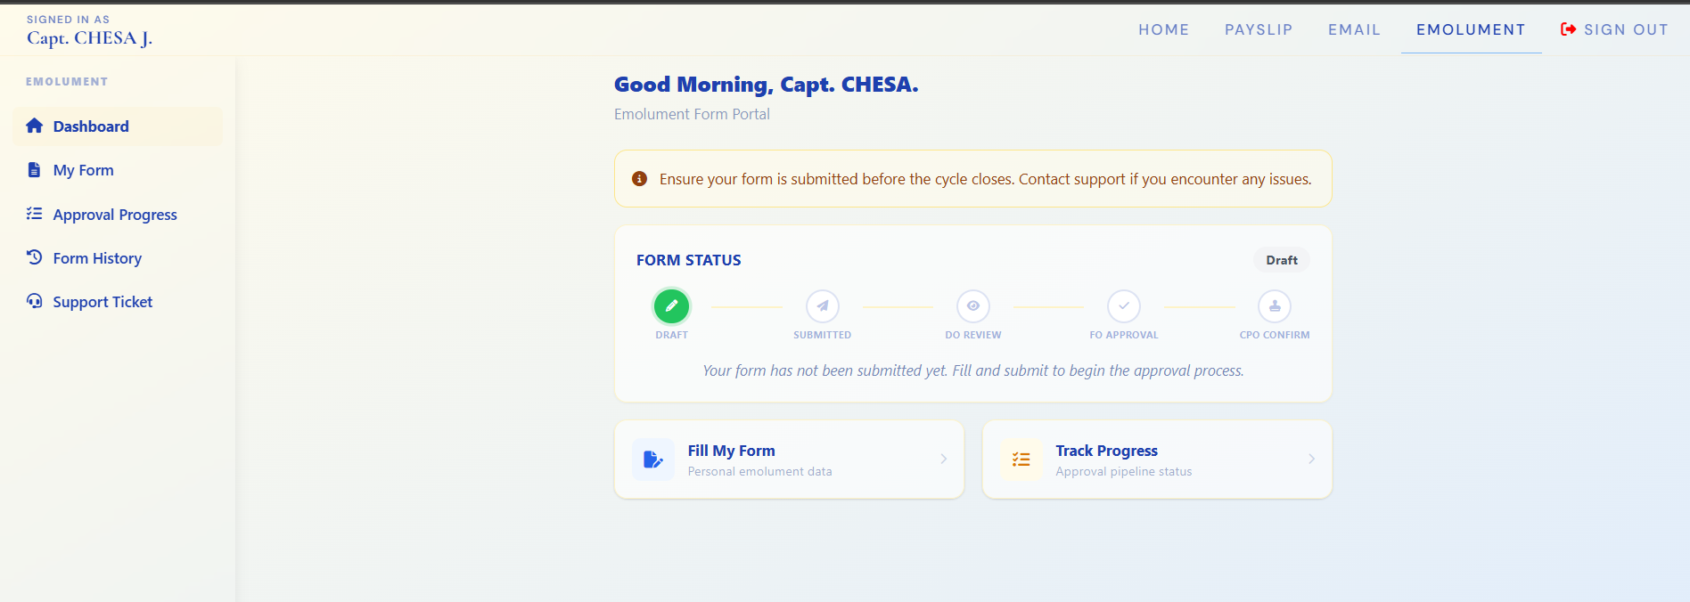
Fig 1.2 Emolument tab in main navigation

STEP 2 | User Fills Emolument Form (User)

After navigating to the Emolument tab, the user completes the emolument form with the required details for the applicable period and submits it.
Dummy Emolument Form Data
Field | Sample Value
Full Name | Chesa Joy
Service Number | NN/1100
Rank | Captain
Ship / Unit | Central Pay Office
Emolument Period | 2027
Status (on submit) | Pending — Awaiting DO

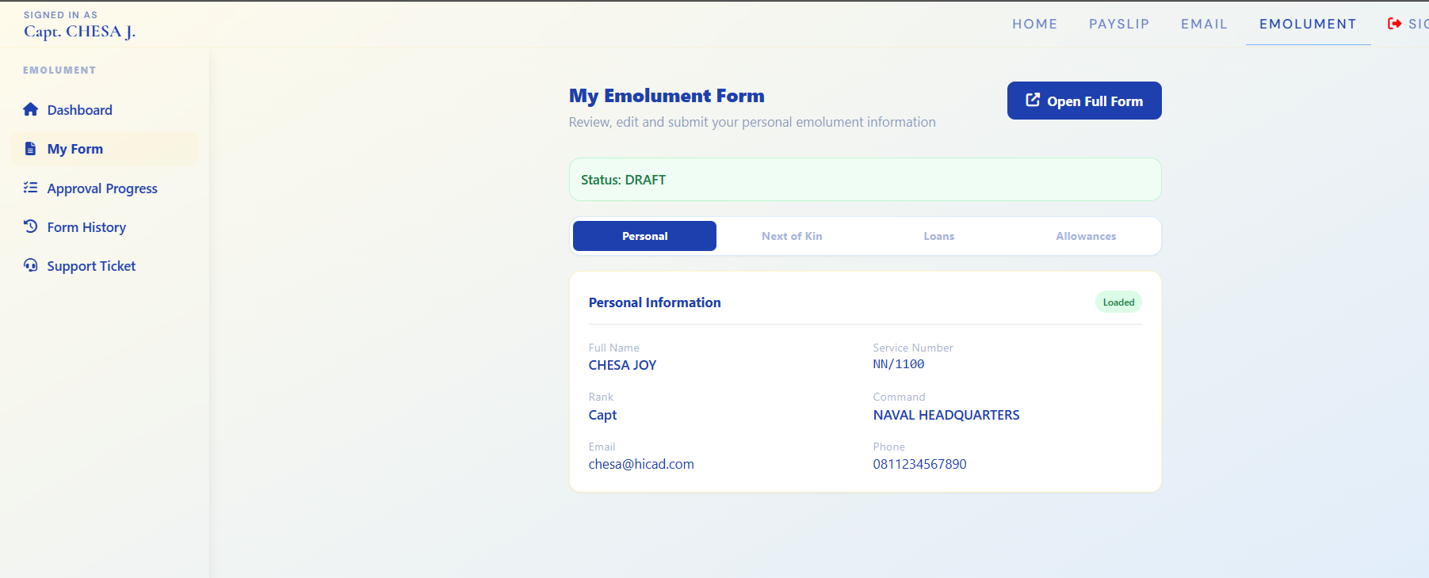Fig 2.1 — Emolument form filled with sample data, prior to submission
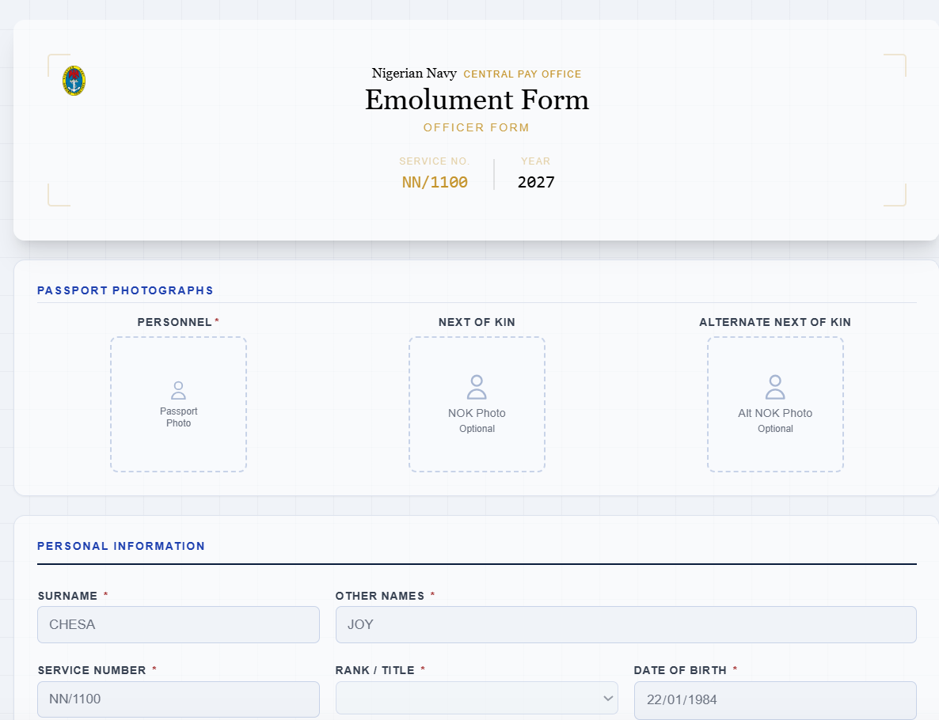

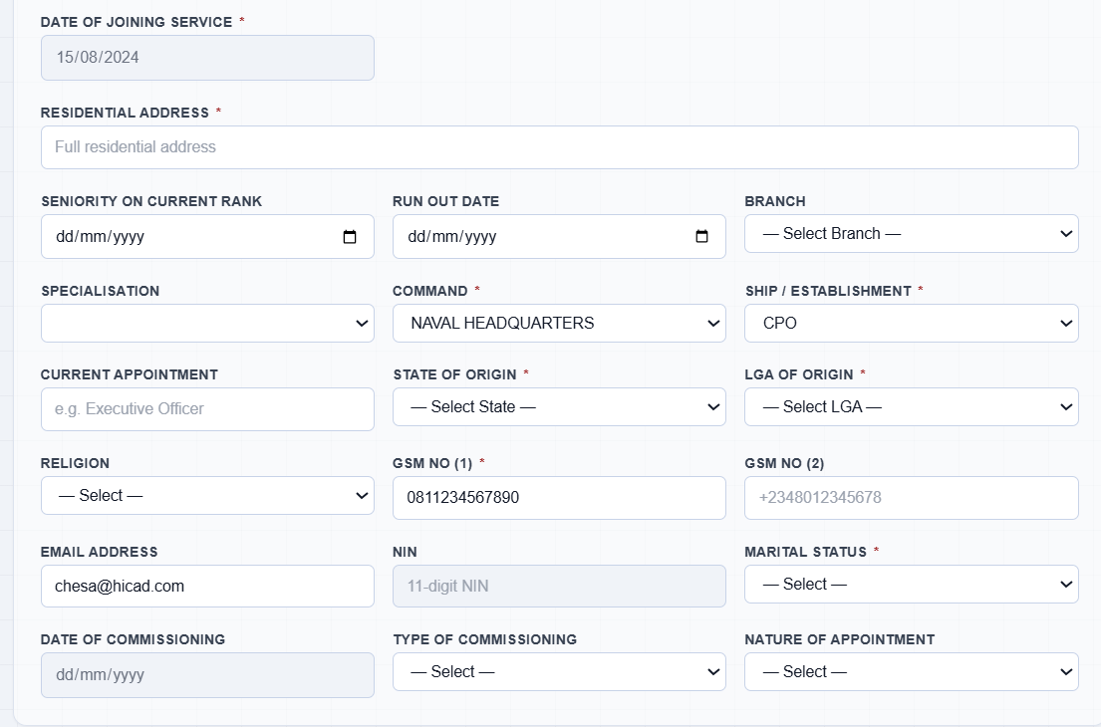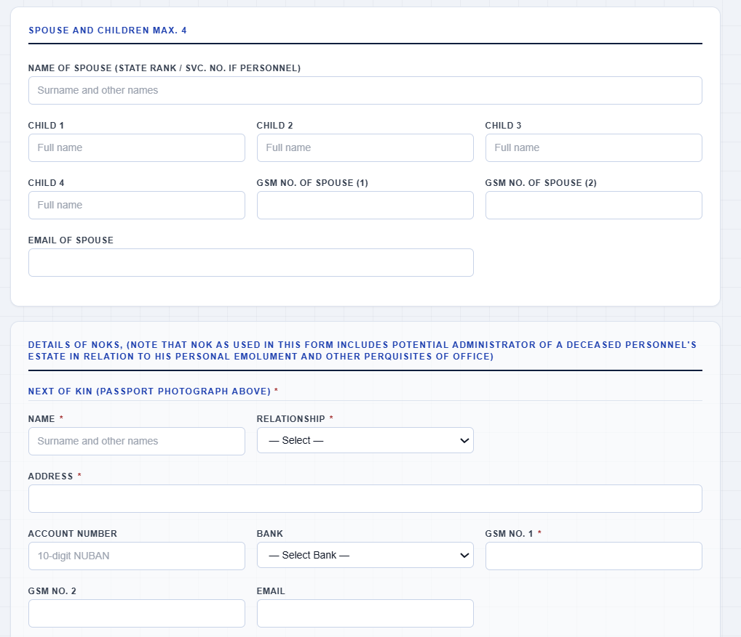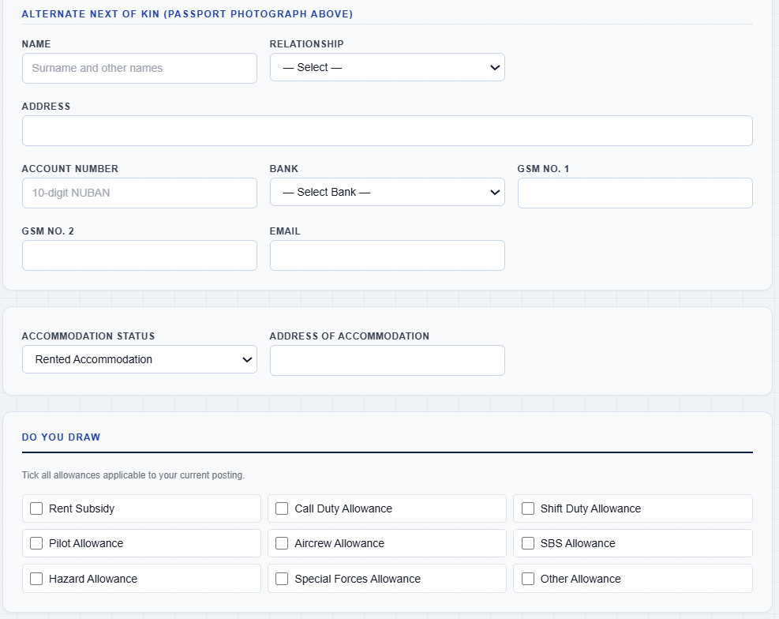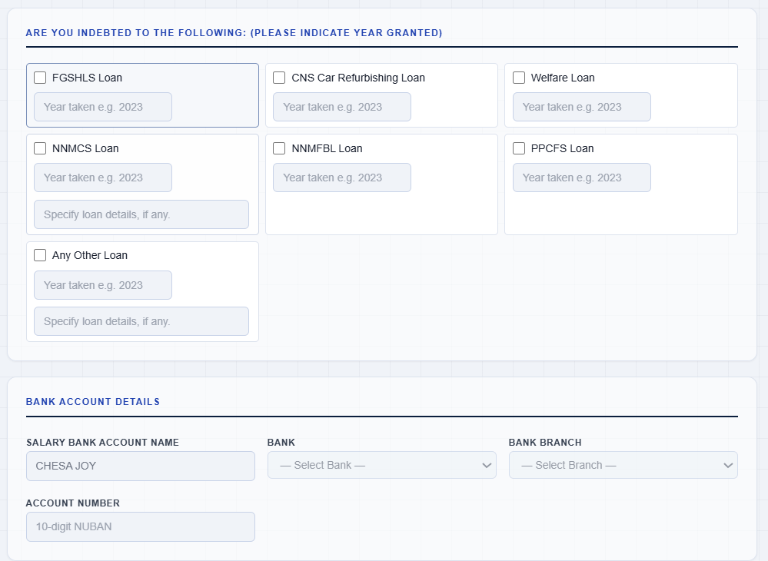
Fig 2.2 — Emolument form filled with sample data, prior to submission

STEP 3 | DO Logs In and Navigates to Emolument Tab (Duty Officer (DO))

The Duty Officer, who is also a user of the system but with an additional special tab/menu, logs into the web application and navigates to the Emolument tab to begin the review process.
Dummy DO Login Data
Field | Sample Value
Username / Service ID | NN/2015X

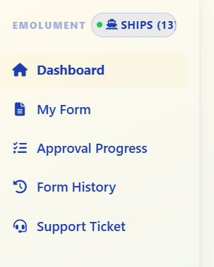
Fig 3.1 —Emolument tab with arrow pointing to collapsed DO Menu

STEP 4 | DO Selects Ship via Special Menu (Duty Officer (DO))

Using the special menu available only to the DO role, the officer selects the relevant ship to filter and view emolument records associated with that SHIP.
Dummy Ship Selection Data
Field | Sample Value
Special Menu | Select Ship
Ship Selected | Central Pay Office
Records Found | 1 pending emolument submissions

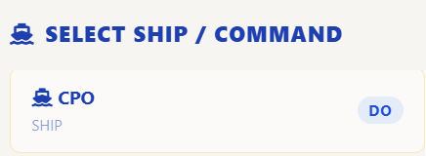
Fig 4.1 — Special menu showing dropdown/list of ships for DO to select

STEP 5 | DO Views Stats Page, Validates or Rejects (Duty Officer (DO))

The DO views the Statistics page for the selected ship, navigates to the Pending section, and validates or rejects the first user record in the queue.
Dummy Stats Page Data
Field | Sample Value
Ship | Central Pay Office
Total Submissions | 1
Pending | 1
Approved | 0
Rejected | 0
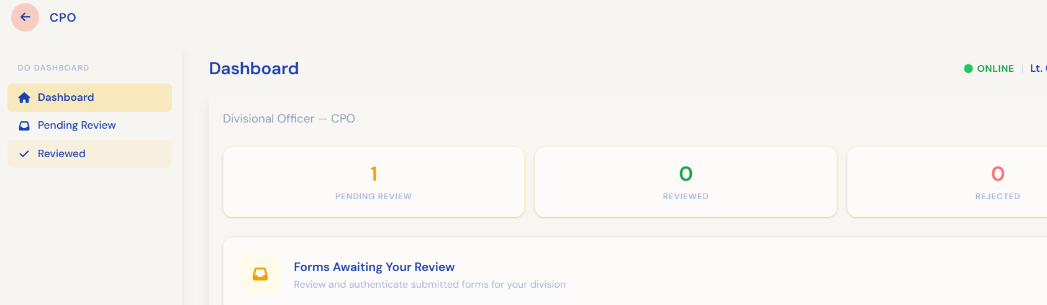 Fig 5.1 — Stats page

Note: If the DO rejects the record: the record's status is set to Draft/Null and the approval trail is cleared. The user must resubmit, and the record restarts from Submission → DO → FO → CPO.
Outcome A — DO Approves
Field | Value
Status | Pending — Awaiting FO
Approval Trail | Submitted → DO Reviewed

Outcome B — DO Rejects
Field | Value
Status | Draft / Null
Approval Trail | Cleared — restarts from Submission
Rejection Reason (sample) | Incorrect period selected

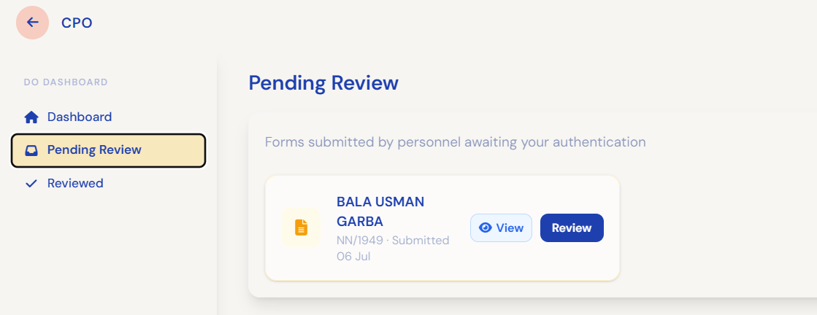 Fig 5.2 — Pending Page, with Single Record Awaiting Action

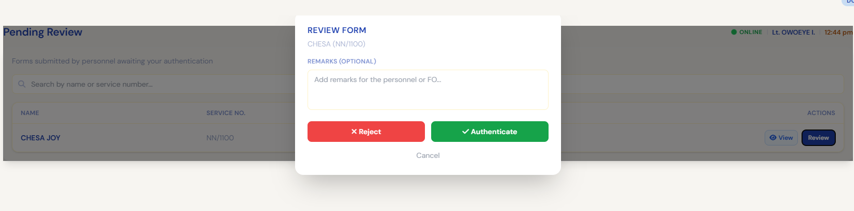Fig 5.3 — Validate/Reject confirmation dialog with reason field
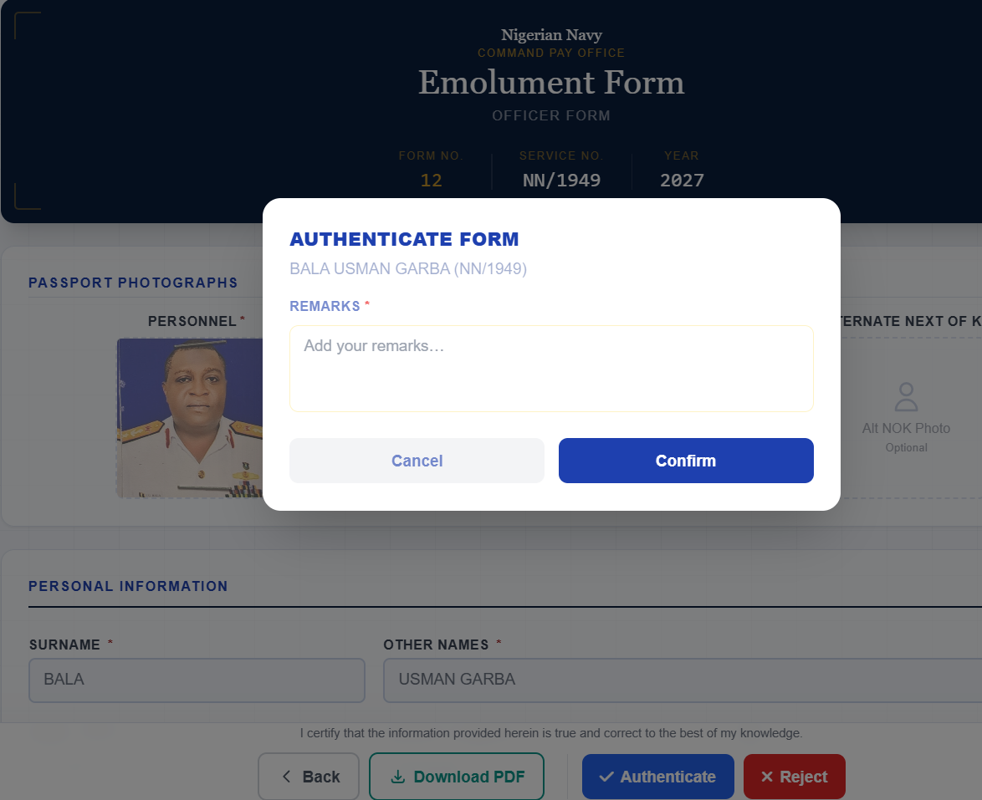
Fig 5.4 — Validate/Reject confirmation dialog with reason field within the form

STEP 6 | FO Selects Ship, Views Stats, Validates or Rejects (Finance Officer (FO))

The Finance Officer, who also has a special tab similar to the DO, logs in, selects the ship via the special menu, opens the Stats page, goes to Pending, and validates or rejects the first record — following the same process as the DO in Steps 4 and 5.
Dummy FO Data
Field | Sample Value
Username / Service ID | FO/0045
Ship Selected | Central Pay Office
Status Before Review | DO REVIEWED — Awaiting FO APPROVAL

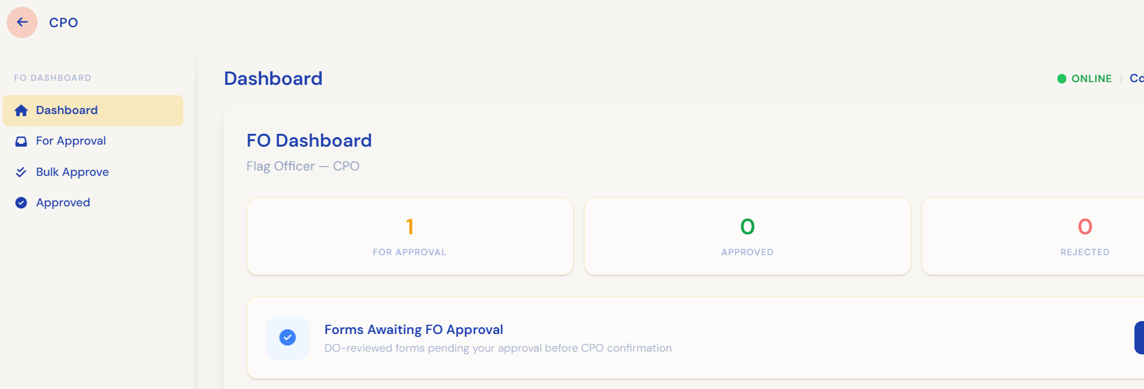 Fig 6.1 — FO special menu, ship selection, and Stats/Pending page
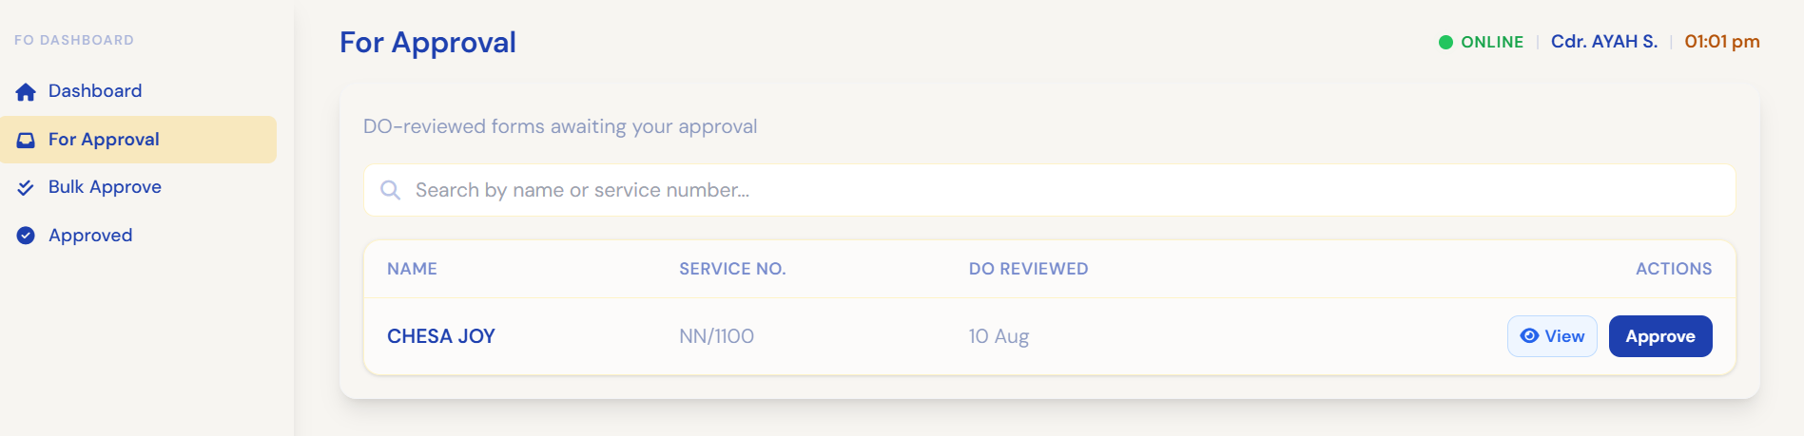 Fig 6.2 — Pending Page, with Single Record Awaiting Action

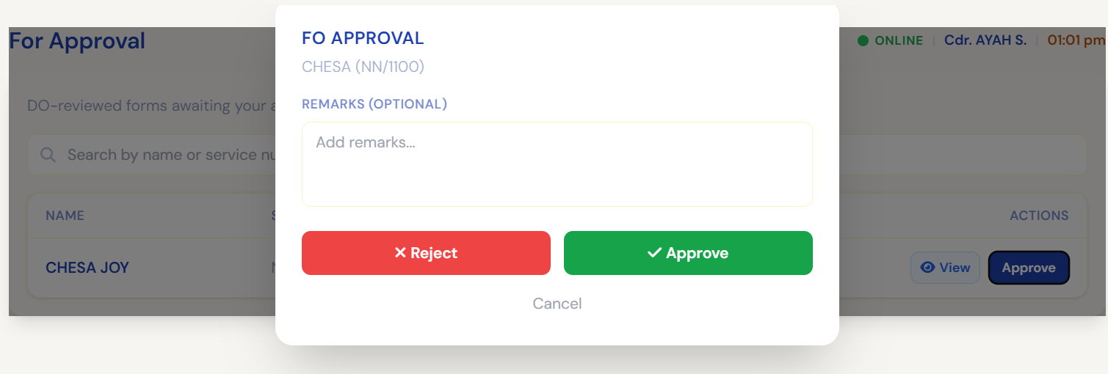Fig 6.3 — Approve/Reject confirmation dialog with reason field
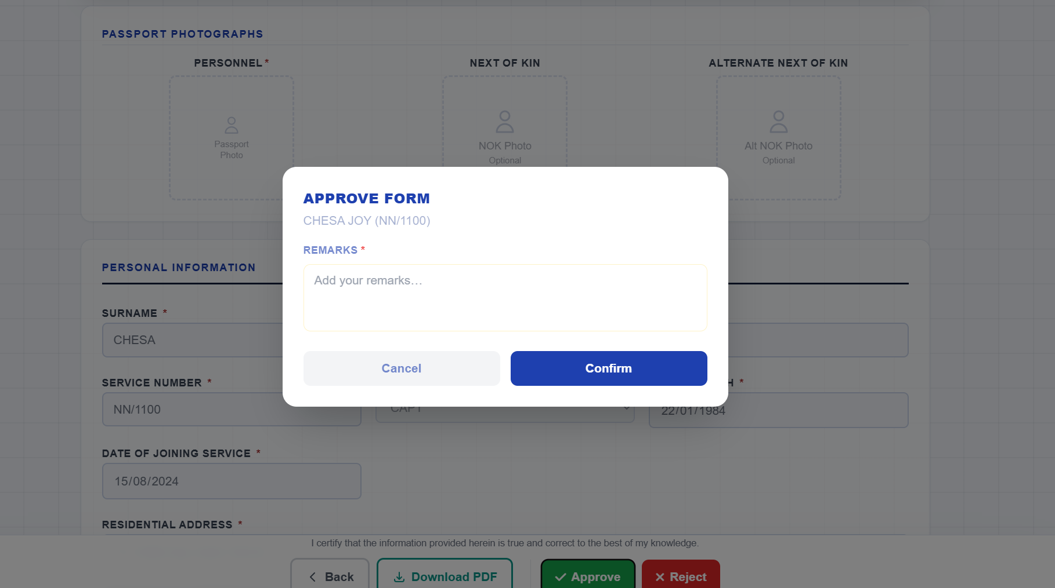
Fig 6.4 — Approve/Reject confirmation dialog with reason field within the form

Outcome A — FO Approves
Field | Value
Status | Pending — Awaiting CPO
Approval Trail | Submitted → DO Reviewed → FO Approved

Outcome B — FO Rejects
Field | Value
Status | Draft / Null
Approval Trail | Cleared — restarts from Submission

STEP 7 | CPO Selects Command, Views Stats, Validates or Rejects (Central Pay Officer (CPO))
The Central Pay Officer, also with a special tab, logs in and selects their command. Unlike the DO and FO, who work one ship at a time, the CPO sees every ship under the command in a single queue and may filter by ship or by payroll class. From there the CPO opens the Stats page, goes to Pending, and validates or rejects the first record — the same process followed by the DO and FO.
Dummy CPO Data
Field | Sample Value
Username / Service ID | CPO/0011
Command Selected | NAVAL HEADQUATERS
Status Before Review | FO_APPROVED — Awaiting CPO_CONFIRMATION

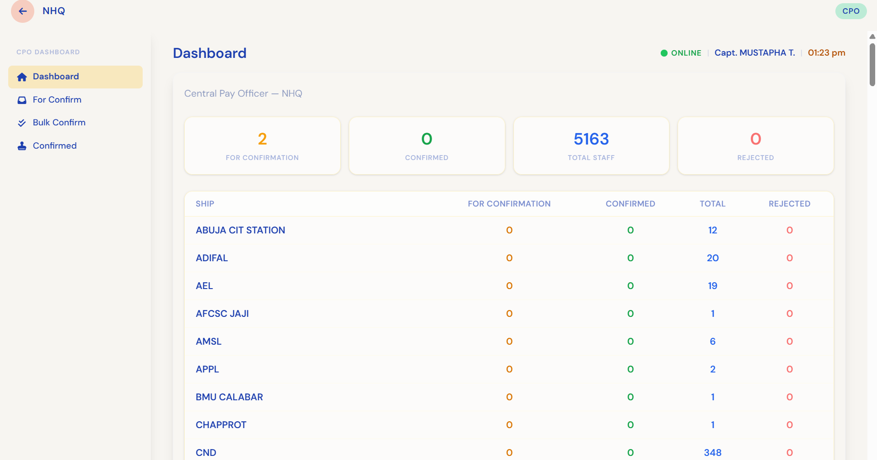
Fig 7.1 — CPO special menu, command selection, and Stats/Pending page
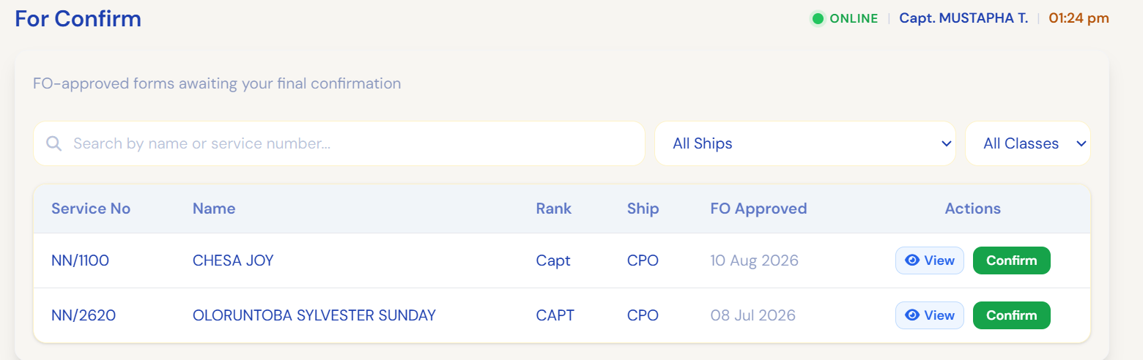
Fig 7.2 — CPO pending page, with records awaiting actions
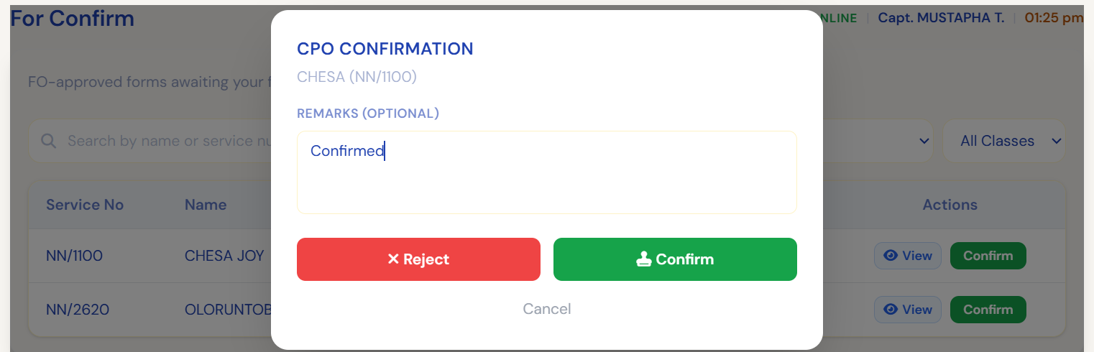
Fig 7.3 — Confirm/Reject confirmation dialog with reason
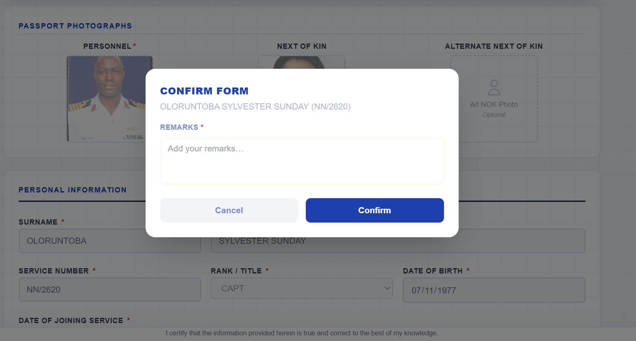
Fig 7.4 — Confirm/Reject confirmation dialog with reason within form

Outcome A — CPO Approves (Final Approval)
Field | Value
Status | Approved — Awaiting Emol Admin
Approval Trail | Submitted → DO Reviewed → FO Approved → CPO Confirmed

Outcome B — CPO Rejects
Field | Value
Status | Draft / Null
Approval Trail | Cleared — restarts from Submission

STEP 8 | Emol Admin Verifies and Syncs to Payroll (Emolument Administrator)

Once approved by the CPO, the record reaches the Emolument Admin. The Emol Admin verifies the user's record and syncs it to the existing payroll infrastructure, marking the user as present for the applicable emolument period.
Dummy Emol Admin Data
Field | Sample Value
Username / Service ID | EMOLADMIN/001
Verification Result | Passed — all approvals confirmed
Payroll System | Naval Payroll Infra (NPI)
Sync Status | Synced Successfully
Emolument Period Marked | 2027

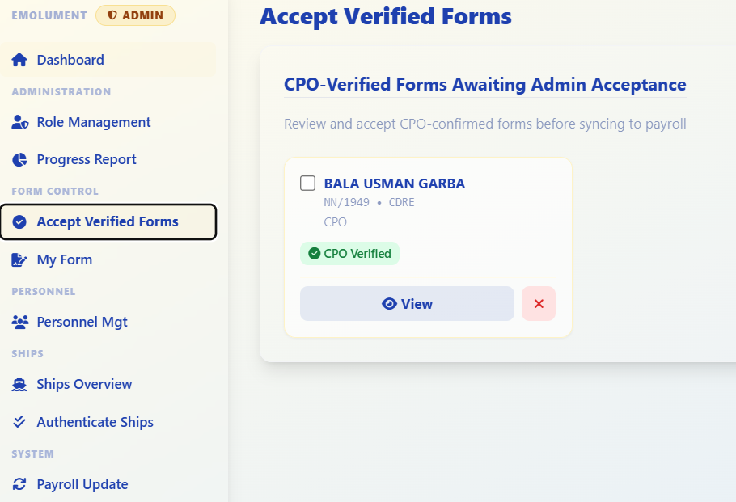 Fig 8.1 — Emol Admin verification screen

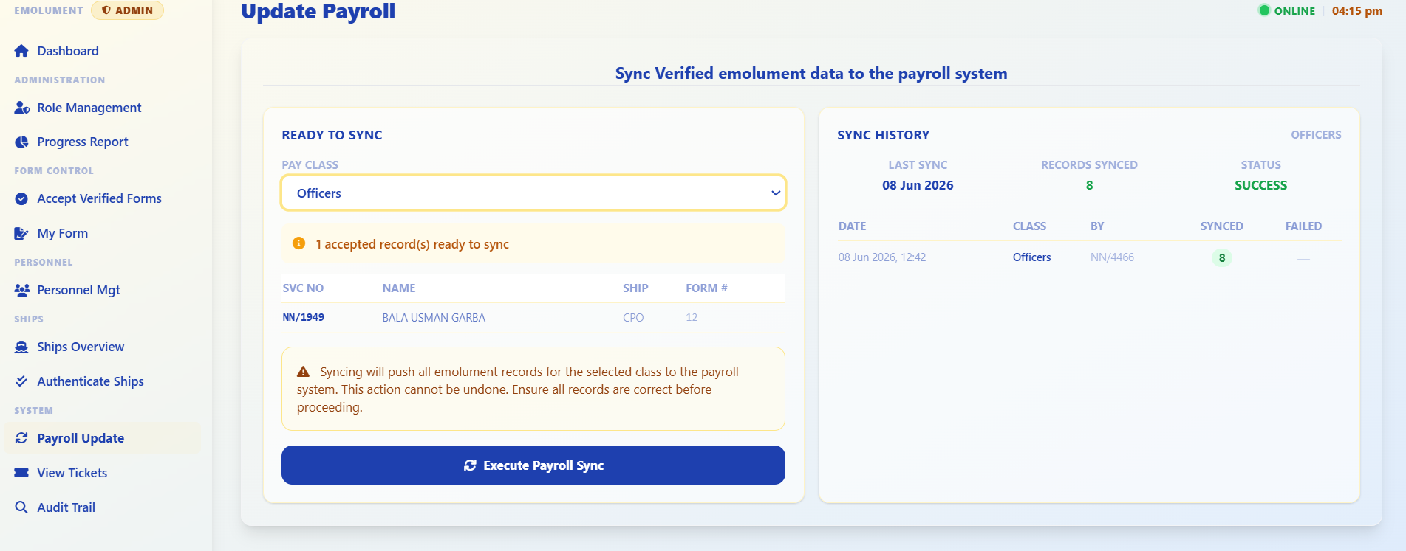 Fig 8.2 — Payroll sync confirmation, user marked Present for period

3. Rejection Handling Summary
At any of the three approval stages (DO, FO, CPO), the reviewer may reject a submission instead of validating it. The table below summarizes the effect of rejection at each stage.
Rejected By | Resulting Status | Approval Trail | Next Action
DO | Draft / Null | Cleared | User must resubmit; restarts from Submission → DO → FO → CPO
FO | Draft / Null | Cleared | User must resubmit; restarts from Submission → DO → FO → CPO
CPO | Draft / Null | Cleared | User must resubmit; restarts from Submission → DO → FO → CPO

4. Appendix — Full Dummy Data Reference
Consolidated reference of the sample record used throughout this document.
Field | Value
Full Name | Chesa Joy
Service Number | NN/1100
Rank | Captain
Ship / Unit | Central Pay Office
Emolument Period | 2027

